**IT 5011**

**Knowledge of Computer components**

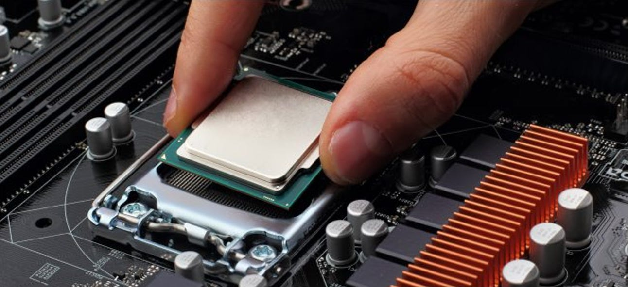

**Namho Kim**

**Internal Components**

* **Mother board**
* **Power supply**
* **Ram**
* **CPU**
* **Graphic card**
* **Network interface card**
* **CD drive**
* **Hard disk drive**

**Mother board**

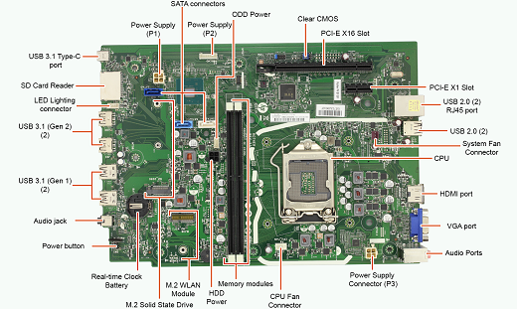

Mother board is main board system in general purpose computer and expandable system. Mother board a single platform to connect all of parts of a computer together such as RAM,CPU, Graphic ports, Audio ports and expansion card or cable directly.

**Power Supply**

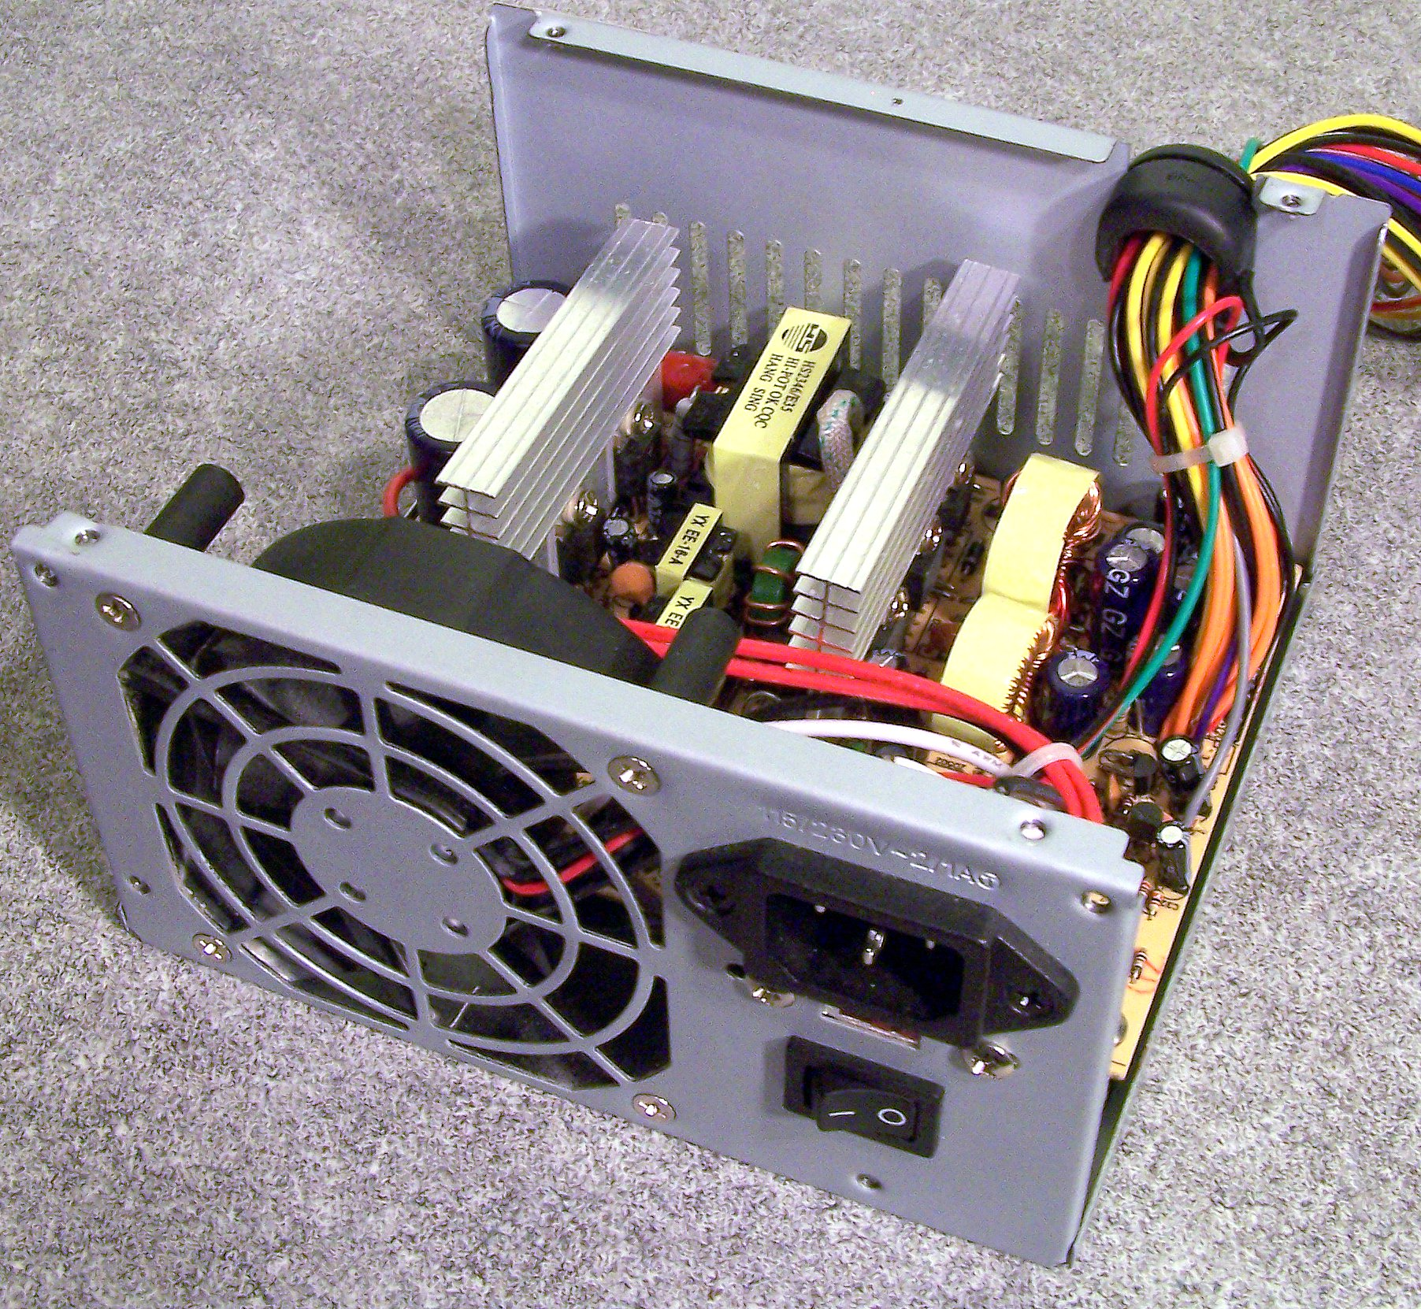

Power supply is a hardware of components of computer that supply electric power to computer. Power supply have a power input connation. Power supply normally located at the back computer. When computer is on the fan inside a power supply should always be running.

**Ram**

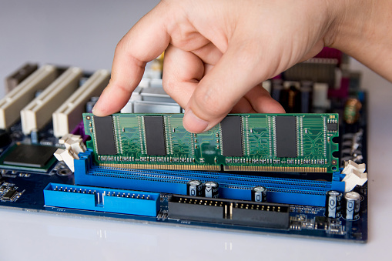

Ram (Random Access Memory) is hardware inside a computer that temporary store data serving as working memory. A memory device that allow to read, write and delete content easily. When computer on CPU stored in the memory device throughout the operation is maintained.

**CPU**

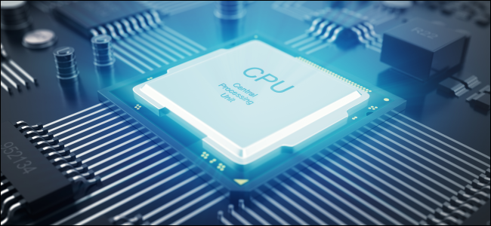

CPU is one of the important parts of the computer as it plays a very important role in memory, interpretation computation and control. The CPU controls the operation of the entire computer while exchanging information with the computer parts.

CPU has a Micro Control Unit (MCU) and SOC (System on Chip) containing both peripheral device. If the surrounding IC is attached separately, it can be called MCU.

**Graphic card**

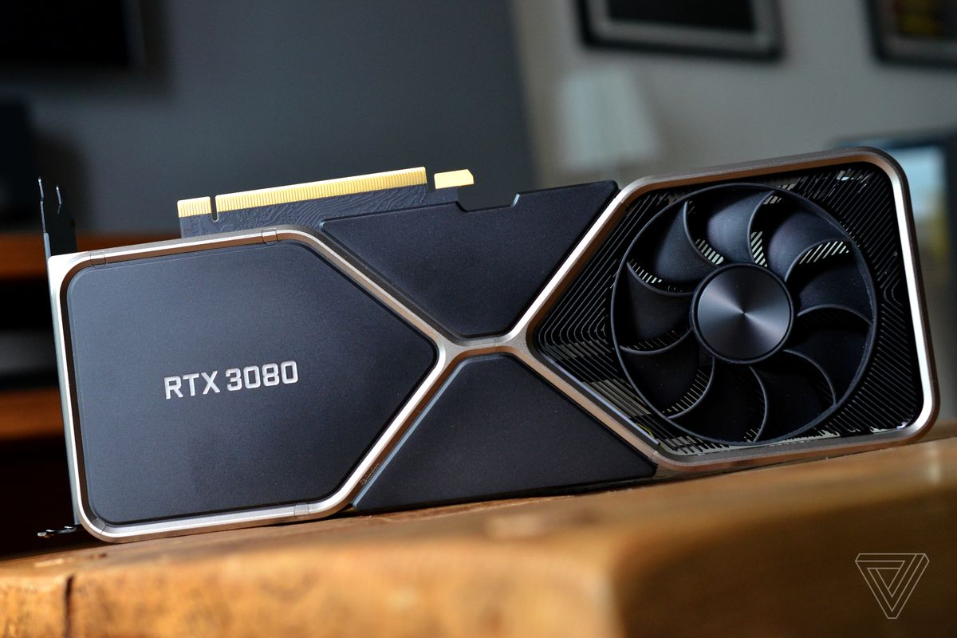

Graphic card is a device that specializes in processing graphics operations under the command of a CPU and convert digital signals into video signals and transmits them to monitor.

**Network interface card**

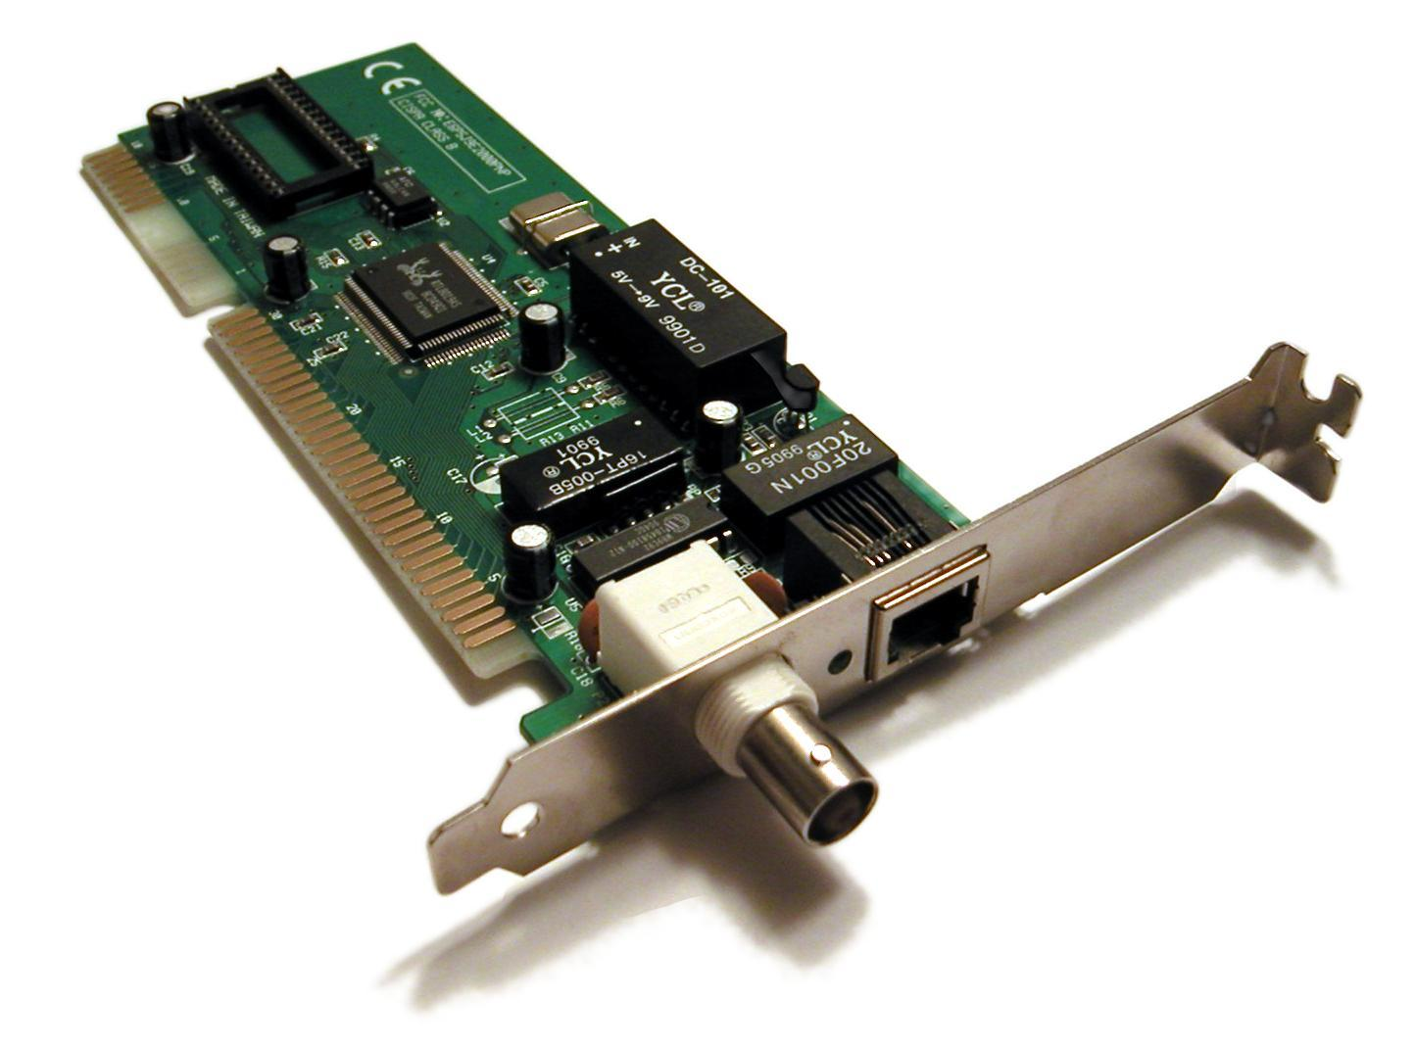

Network interface card is a network equipment. Automatically connect to the required programs and networks. Network interface card loads the users data onto the cable passes it to the hub switch router and it is responsible for delivering it to the CPU.

**CD Drive**

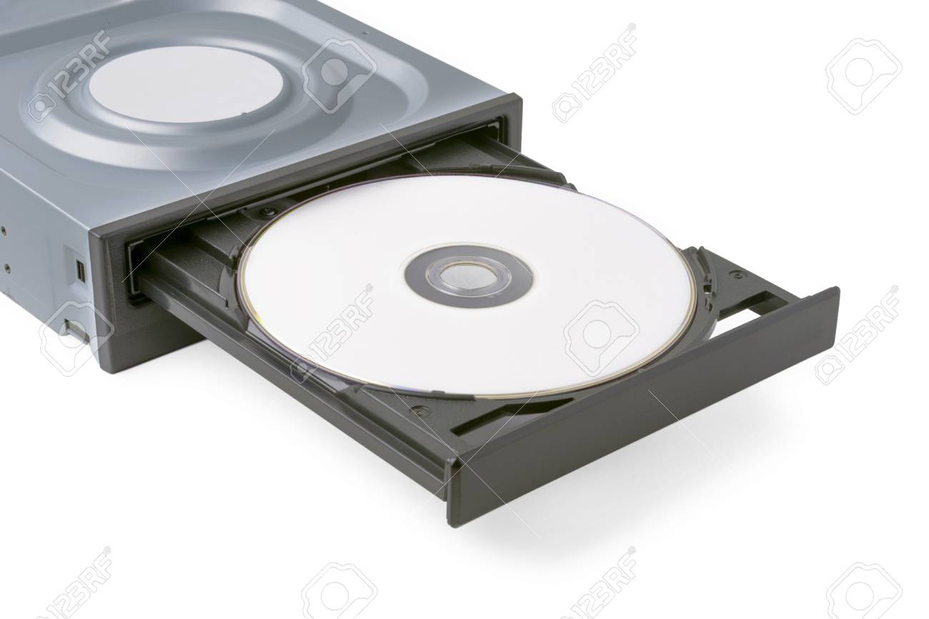

CD drive is a device that your computer uses to read digitally encoded data from a CD.CD drive can install a cd drive inside a computer with connected to one of the computer ports or opening for disk drive access.

**Hard drive**

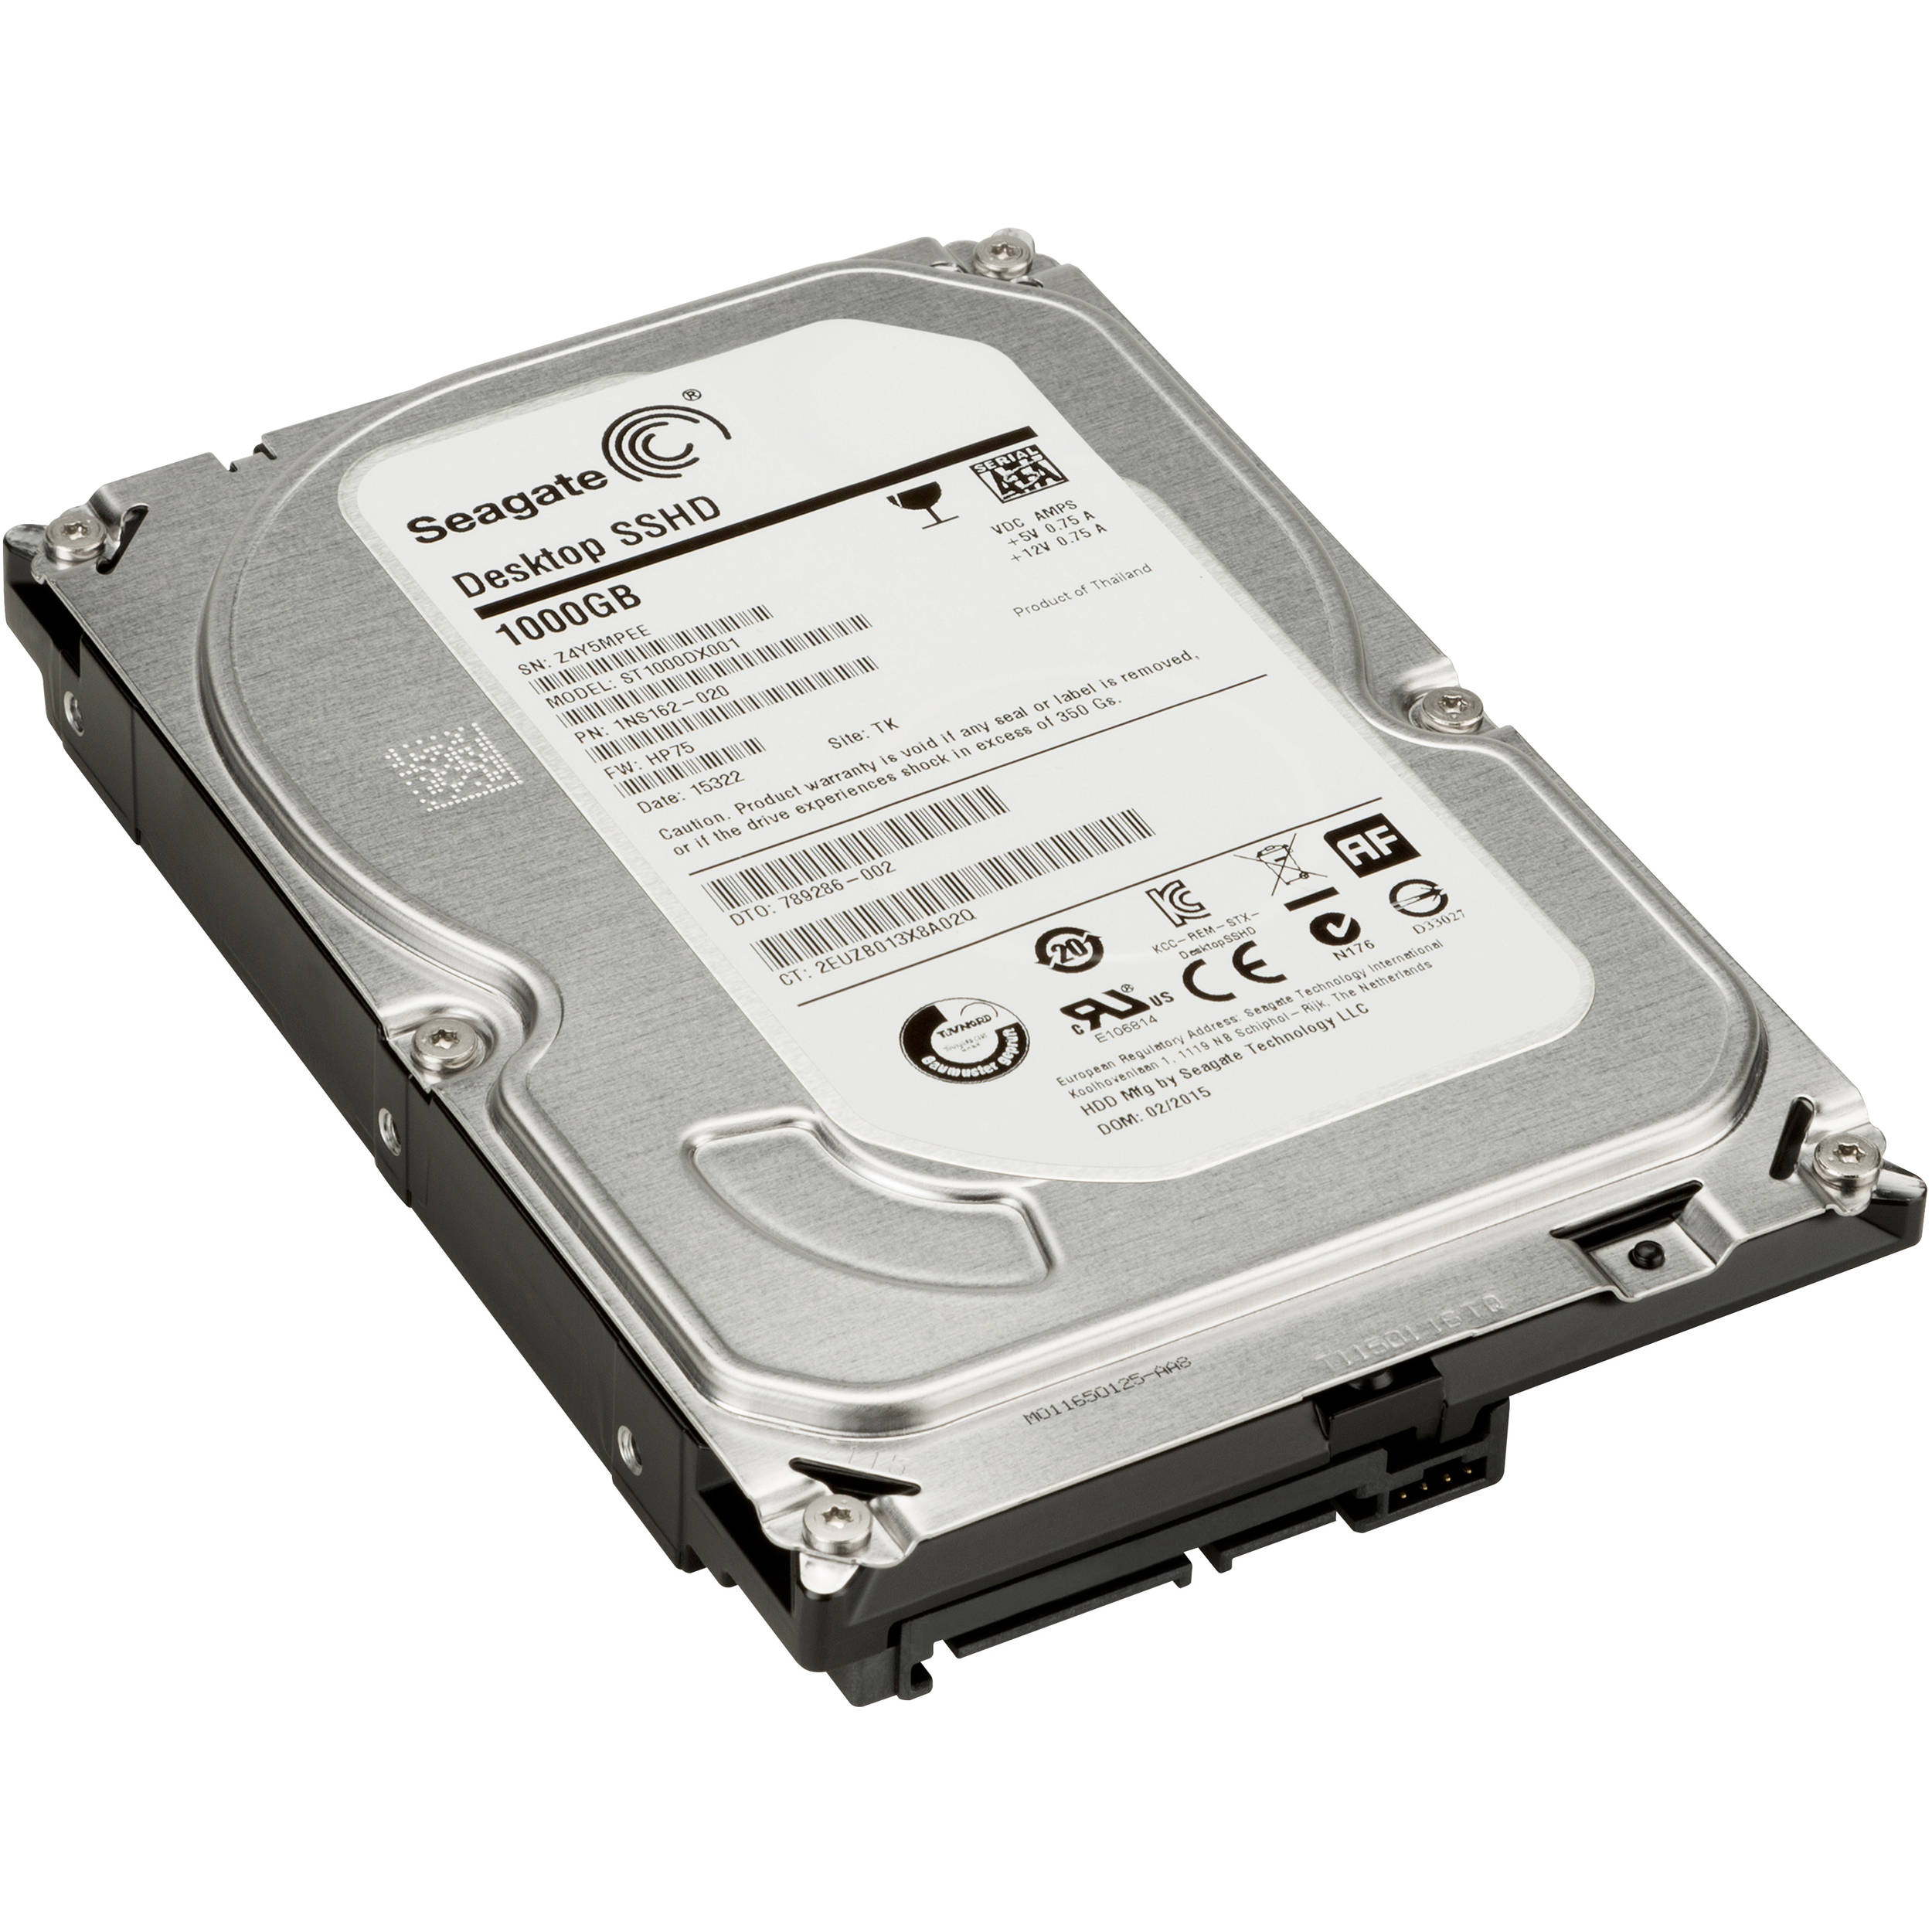

It is a one of the main components of a computer an auxiliary memory device. It mean that is a component that serves to assist the periodic memory, but its role as a non-volatile data repository is much more important than that

**Why do we need an anti-static strap to work with internal computer components? Is there any alternate option available?**

Avoid electrostatic discharge (ESD) as much as possible